S5
Adonay Tesfamichael
IT-214-006
This SQL assignment shows a leagues database. Which stores SEASON, CLUB, TEAM, DIVISION, REGISTERED, COACH, PLAYER AND SCHEDULE
Task 1-ERD Model
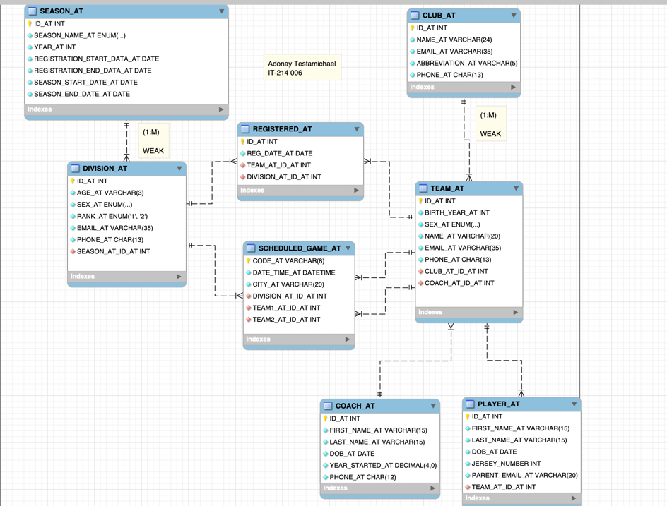
SEASON
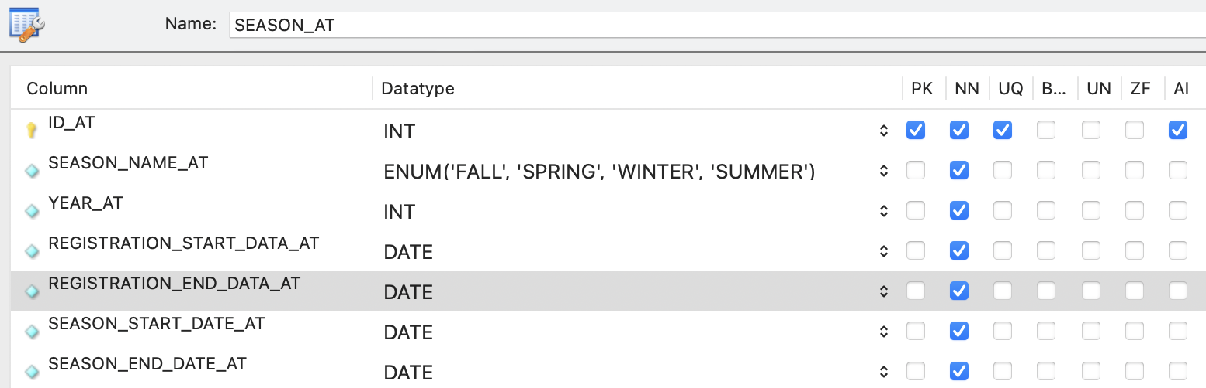
DIVISION
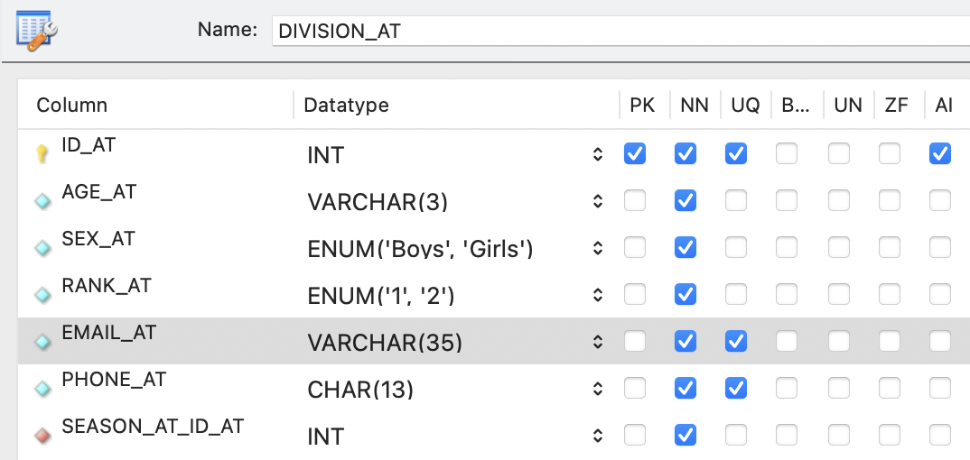
TEAM
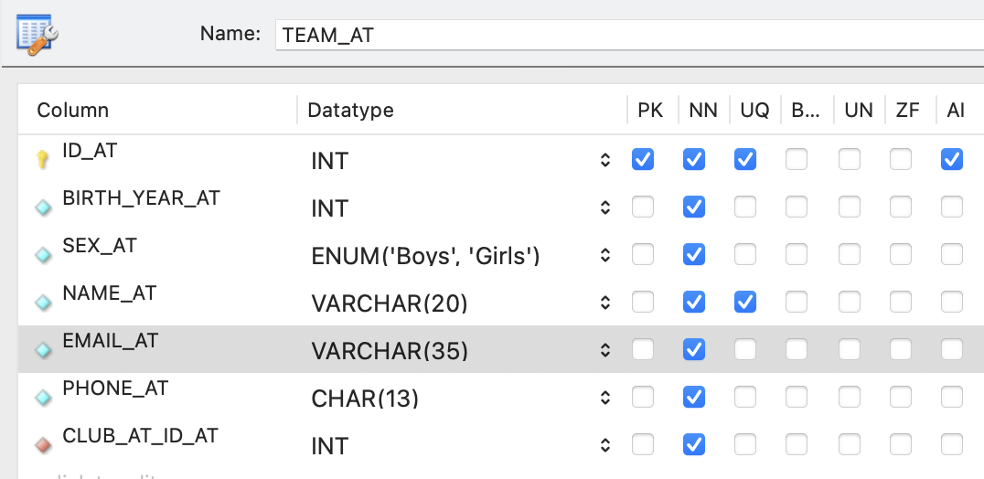
CLUB
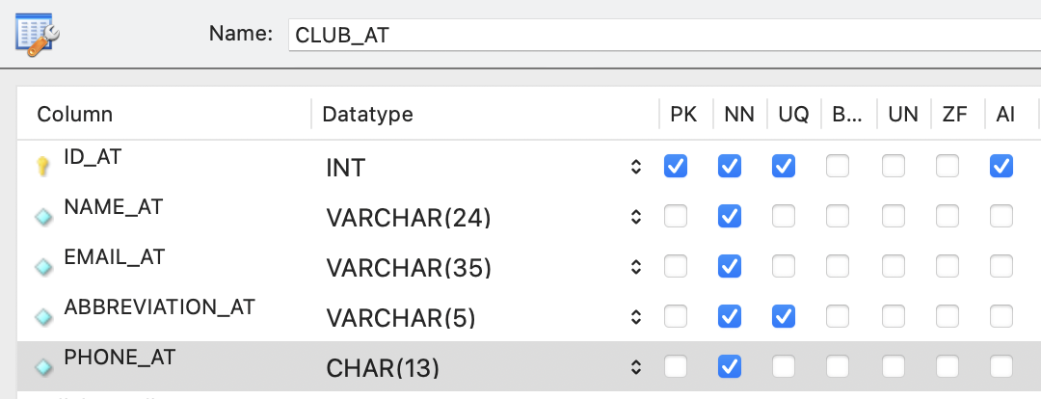
REGISTERED
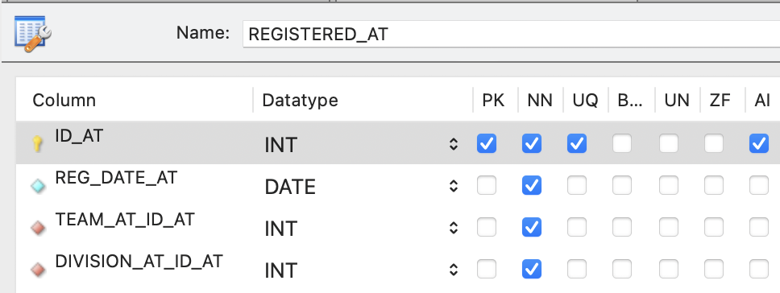

COACH
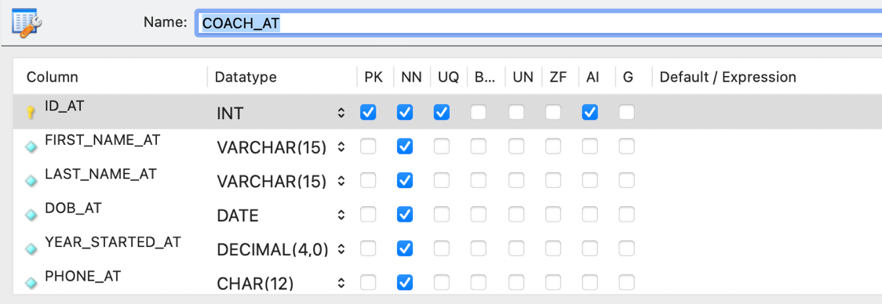
PLAYER
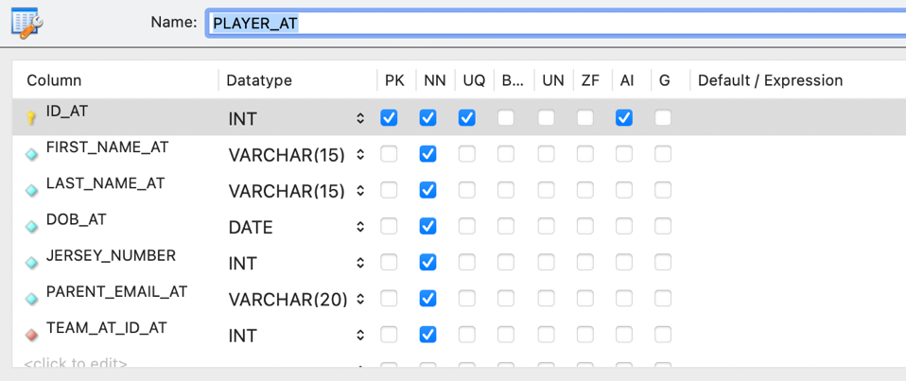
SCHEDULED_GAME_AT

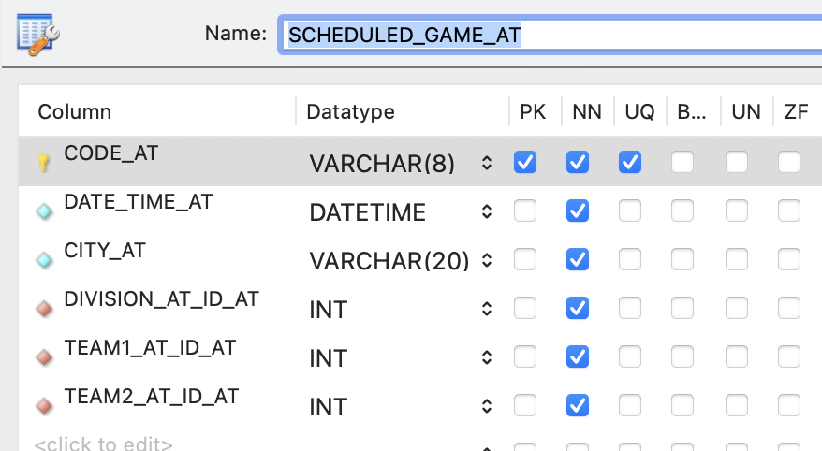

-- Task 2 Create database by Adonay Tesfamichael
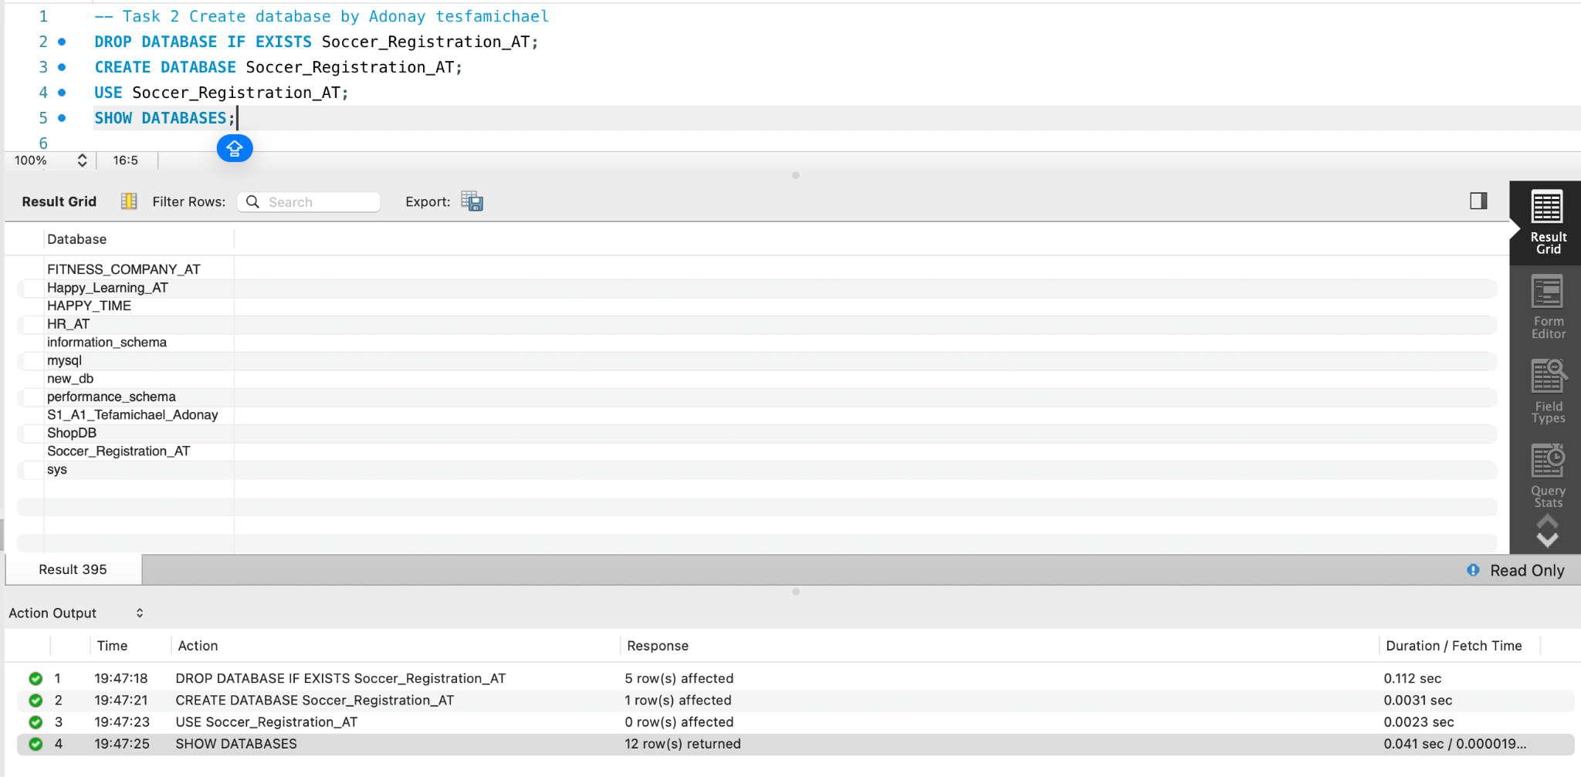
-- Task 3 - Create table by Adonay Tesfamichael
SEASON-
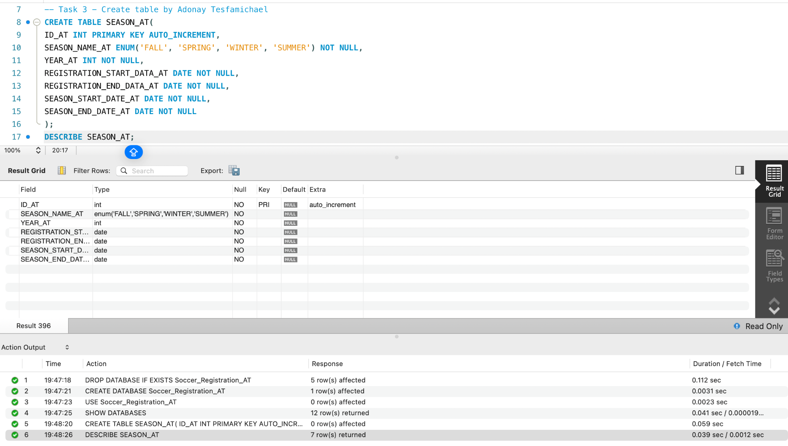
DIVISION-
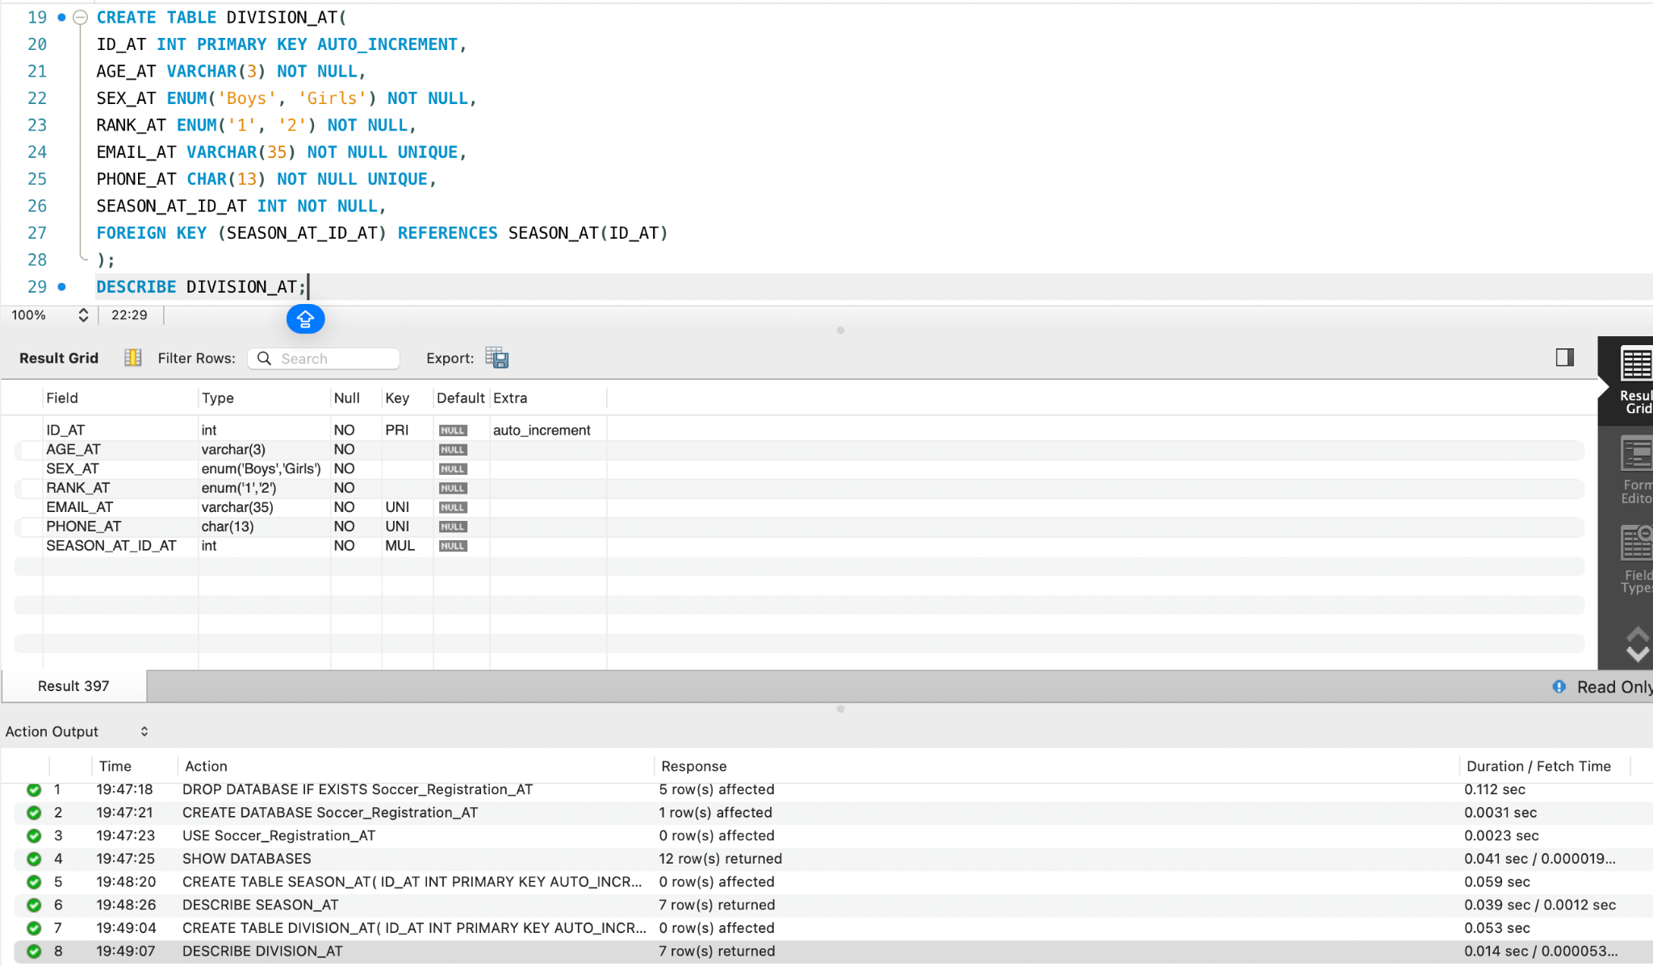
CLUB-

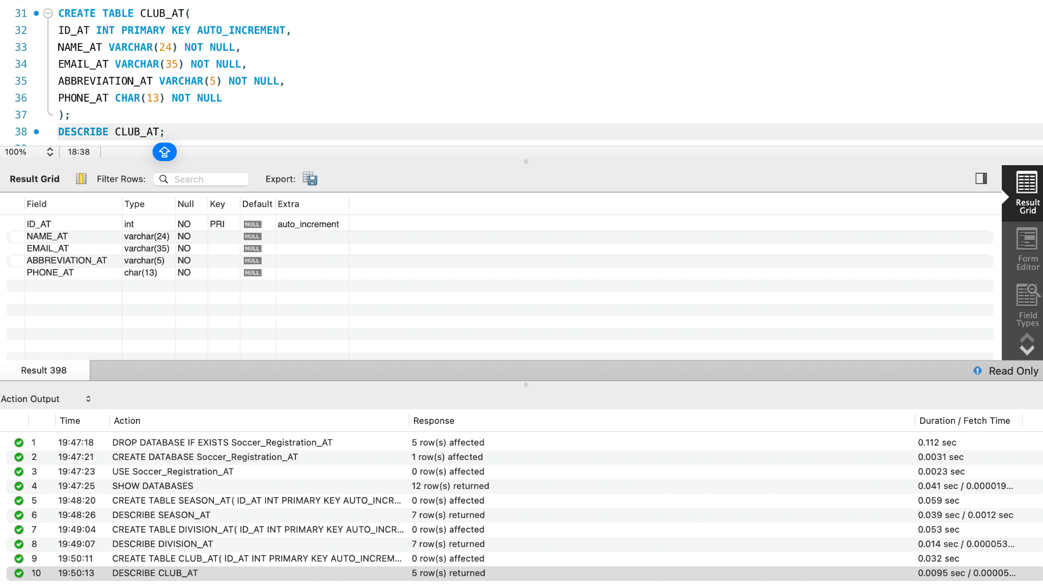

TEAM-
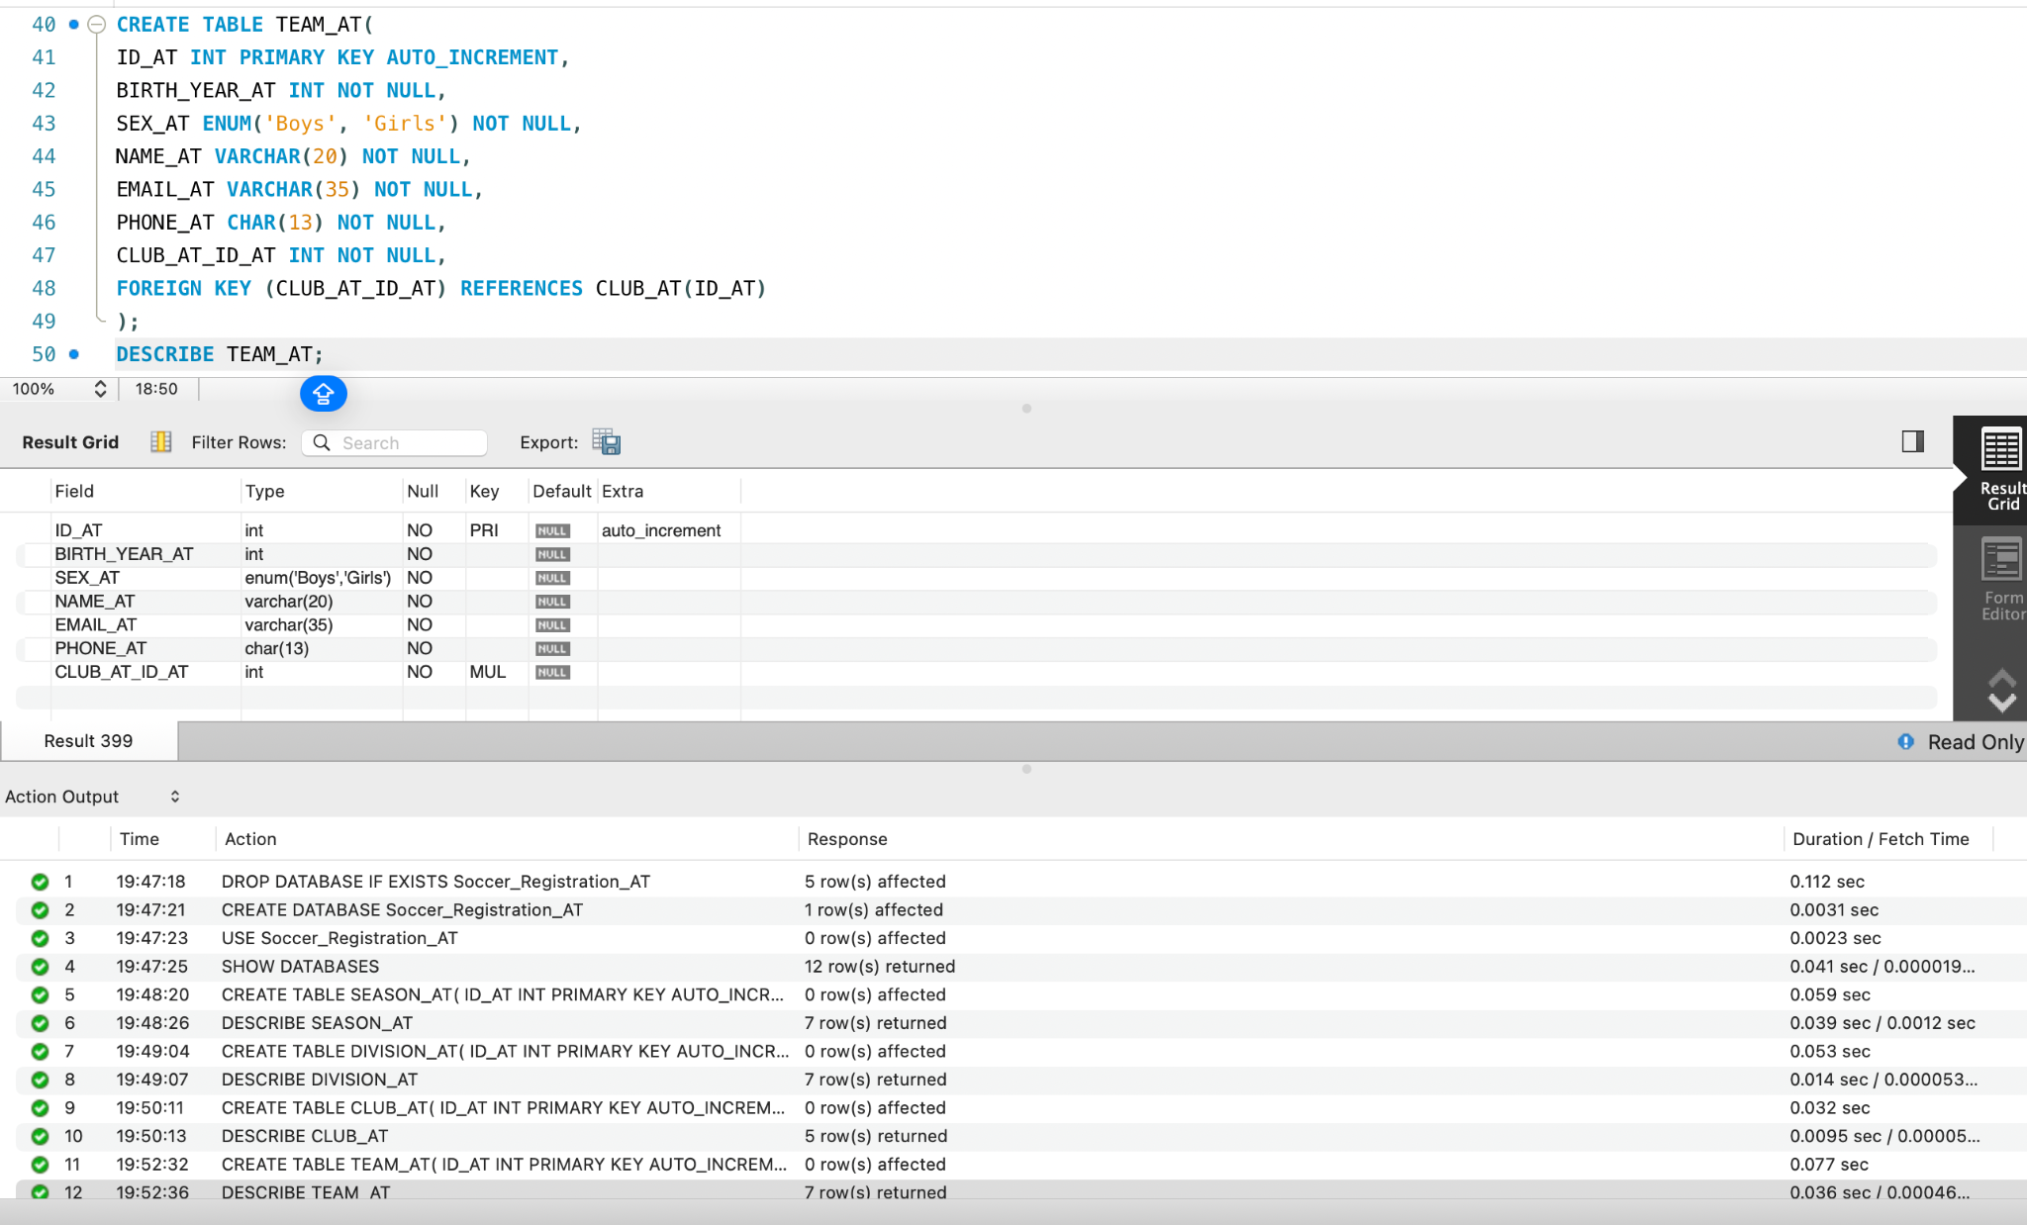
REGISTERED-
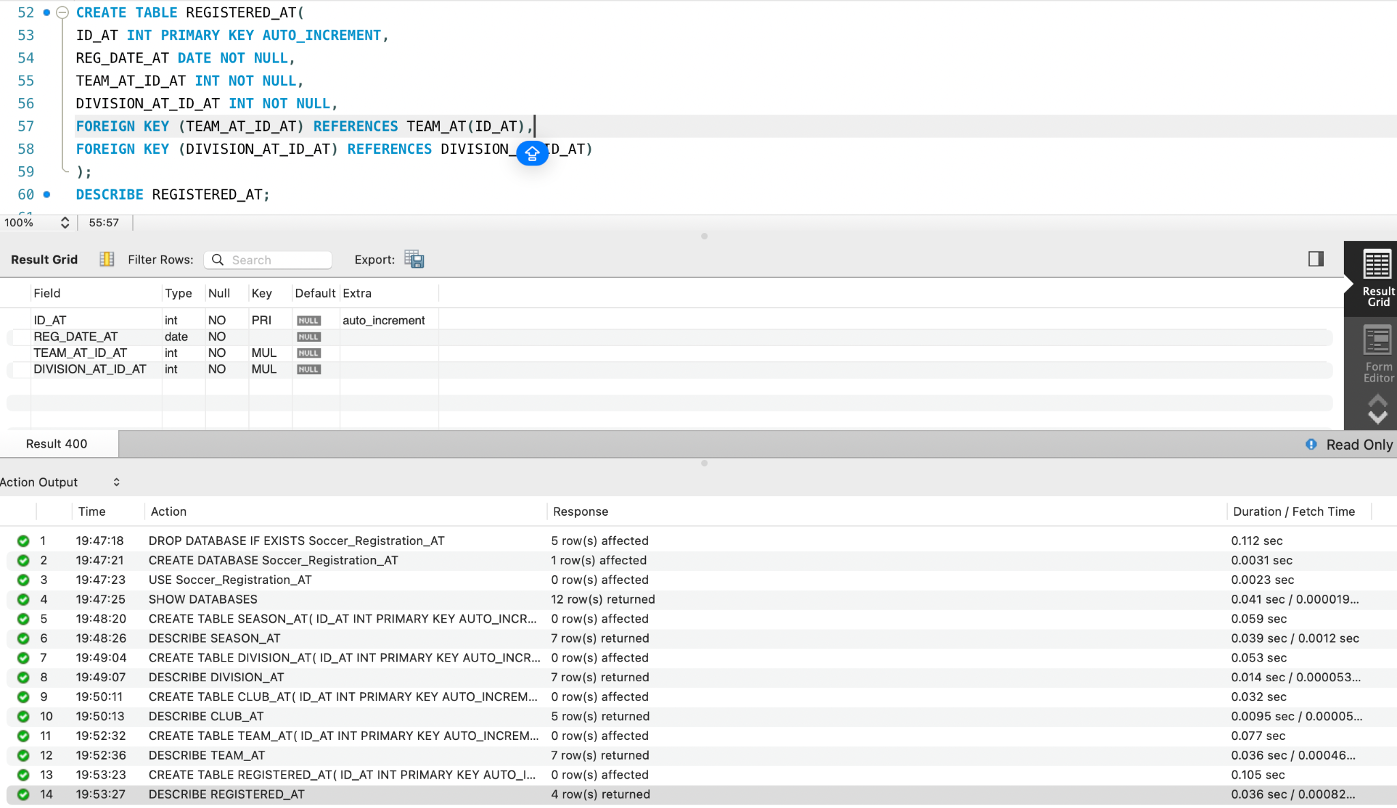

TABLES CREATED
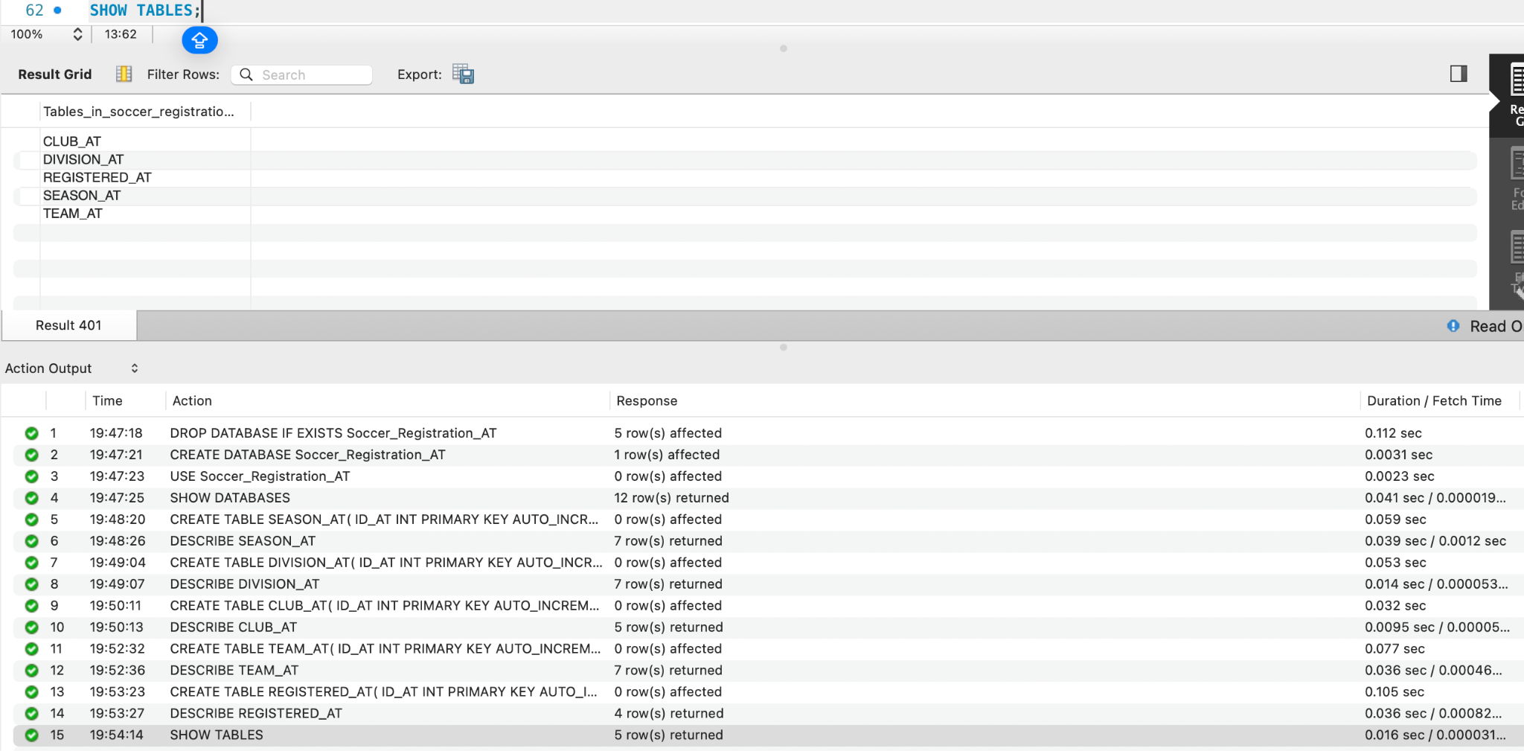

SCHEDULED_GAME_AT

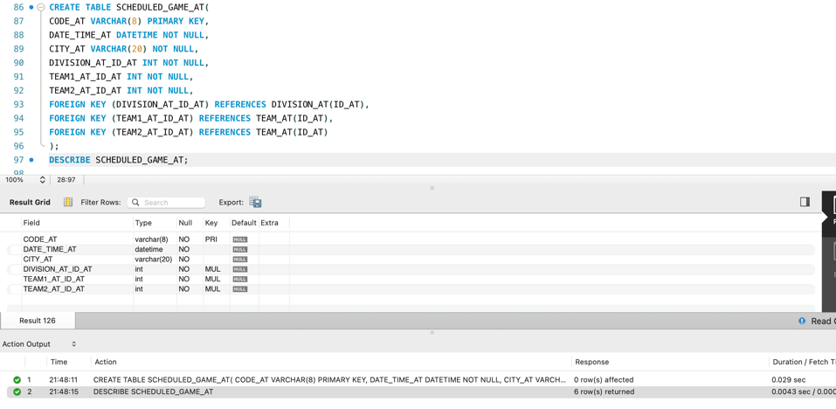

-- Task 4 - Add data by Adonay Tesfamichael

SEASON-
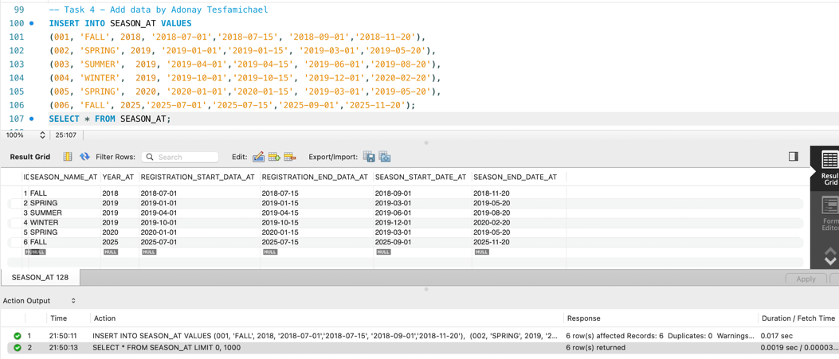

DIVISION-
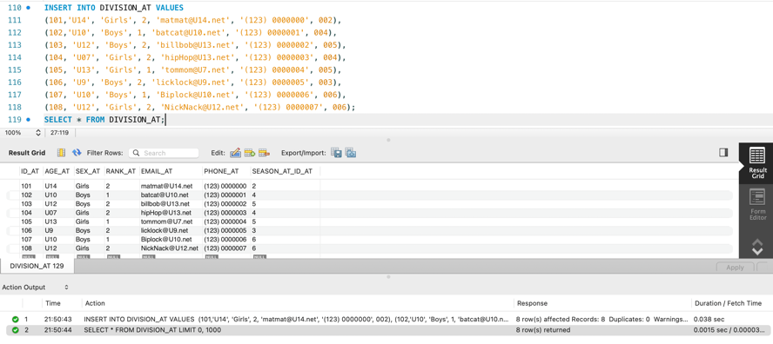

CLUB-

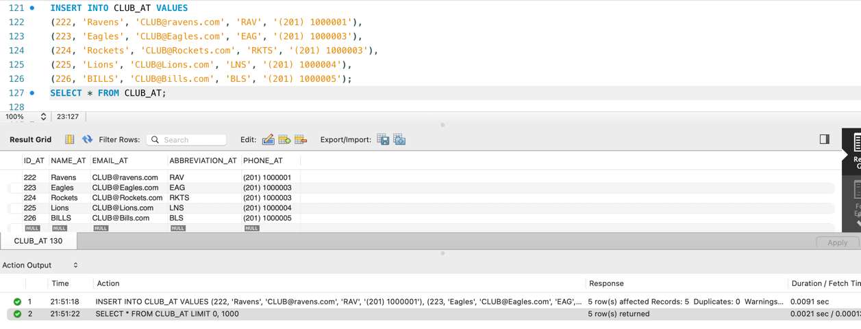
TEAMS-
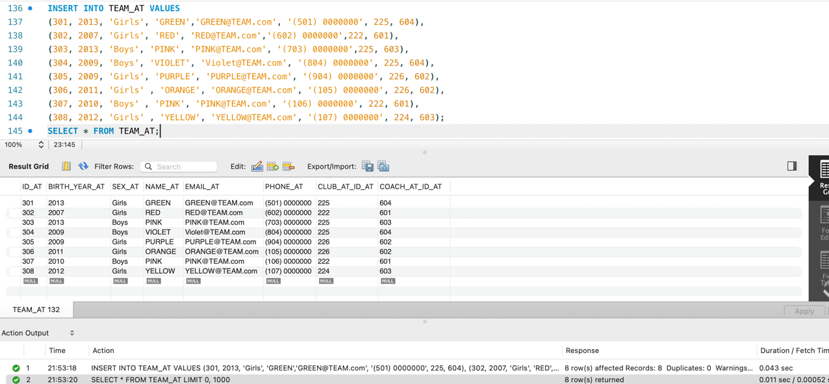
COACH-
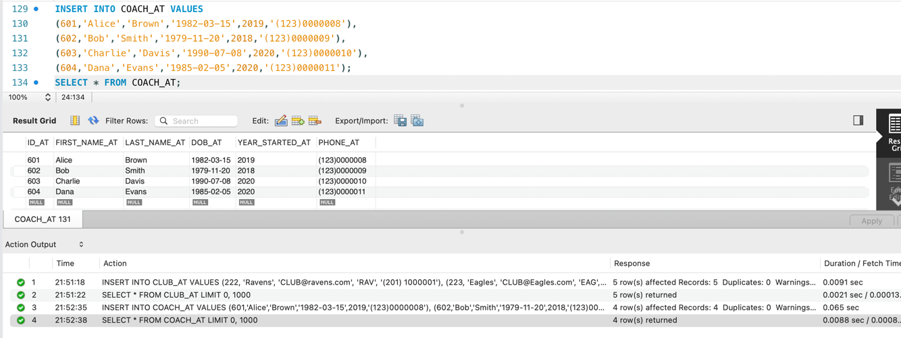
PLAYER-

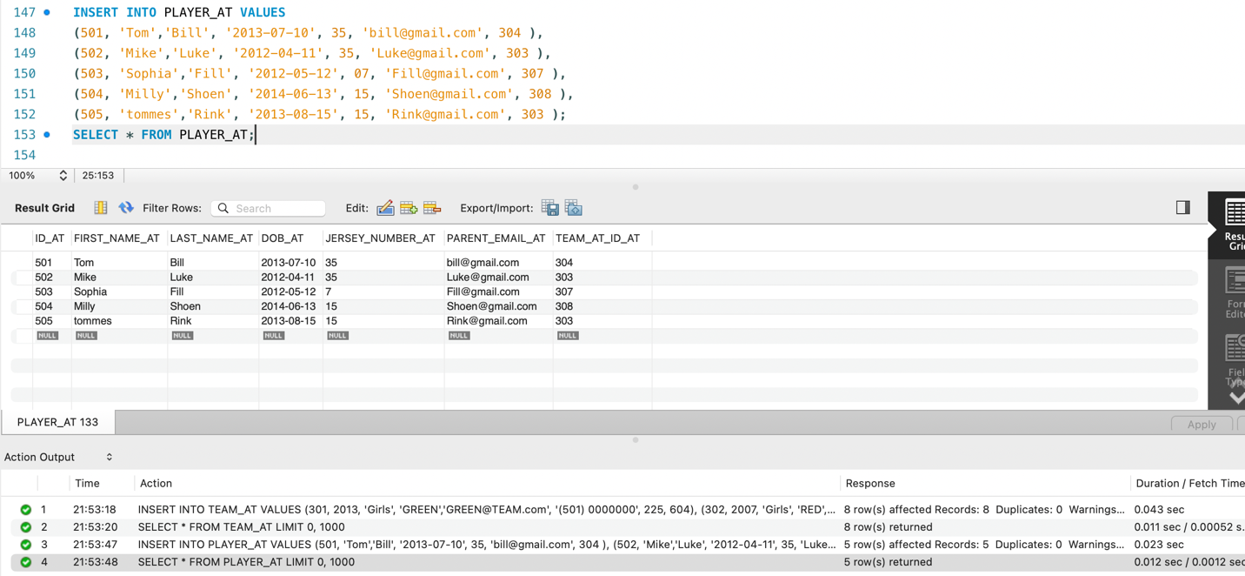
REGISTERED-
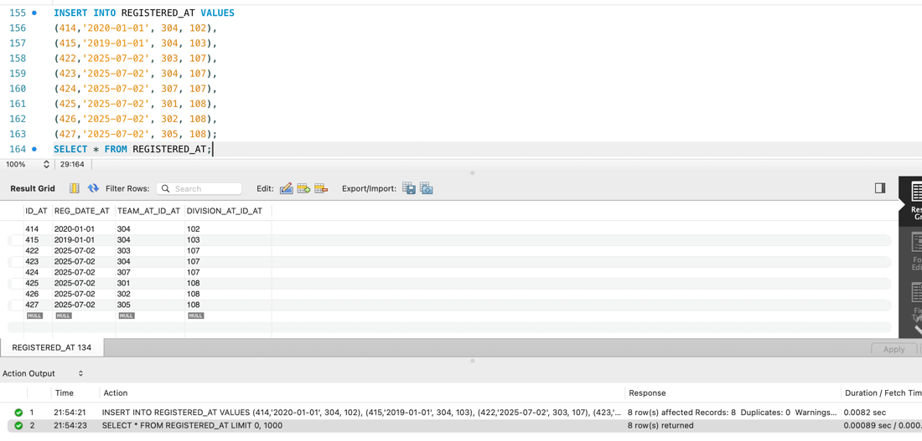

SCHEDULED_GAME_AT
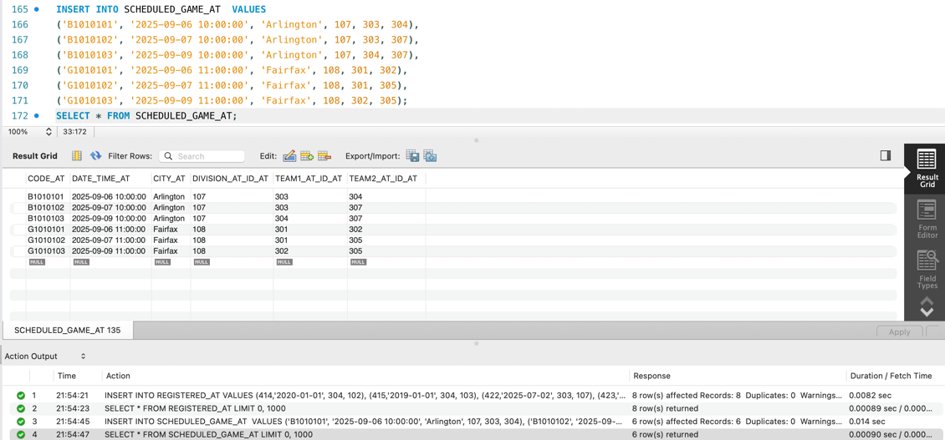

- For each city (in alphabetic order) compute the number of games.
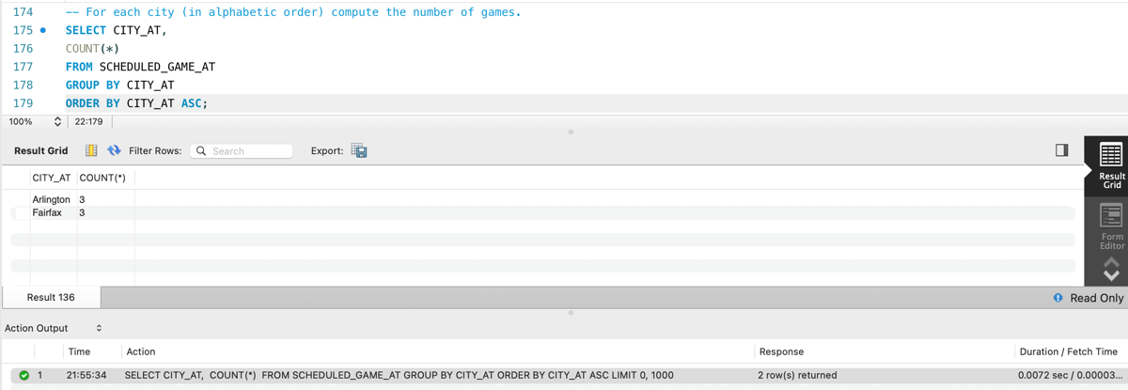
- For each club (in alphabetic order) compute the total number of coaches hired.
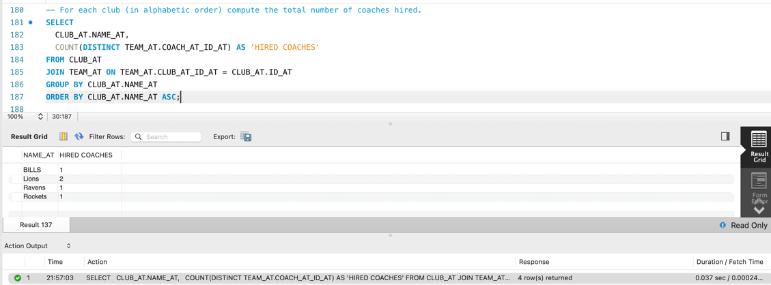
- For each division in the current season compute the total number of clubs.
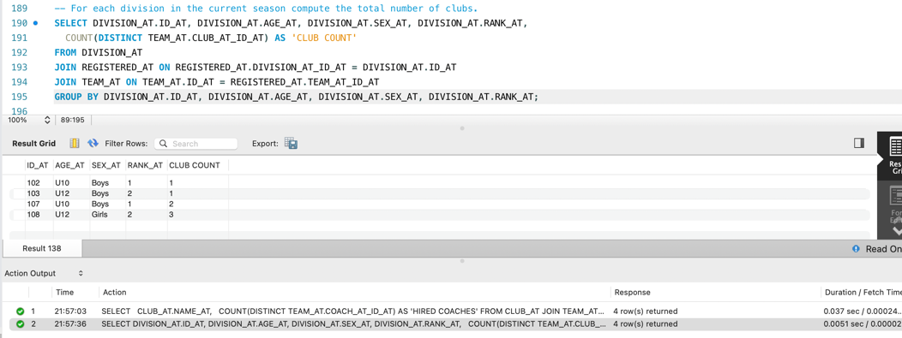

- For each coach (in alphabetic order) compute the total numbers of players.

